Team 4 Bi-Weekly Report 3 - Friday 18th November 2016

**Microsoft Cities Unlock Project**

Created by: Ti Ern Ryan Tan, Stefan Manole, Nadia Yael Mahgerefteh

**Overview**

Over the last two weeks, we have done individual readings on previous work that has already been done. We have created a presentation of our main 4 ideas: route sharing and remote navigation, route suggestions, presenting trending Pol’s and audio/sound reviews providing a short description, user cases and technical problems for each of them. After our client provided us with the priority of experiences to build out we have continued our research into the technical approaches we will follow and have clarified the milestones, requirements, the individual responsibilities and the processes and tools we are going to use. We have set the individual components of our project: Routes, Route sharing, Ionic Map, Ionic profile and friending, Ionic Route sharing and the Ionic route received. For the design we split the project into 2 parts: the server side which will deal with delivering restful API’s to our client app and the App user interface which deals with the user interaction and the app calling the APi’s . We have come up with a set of initial problems that we may face in the future and created the system diagram.

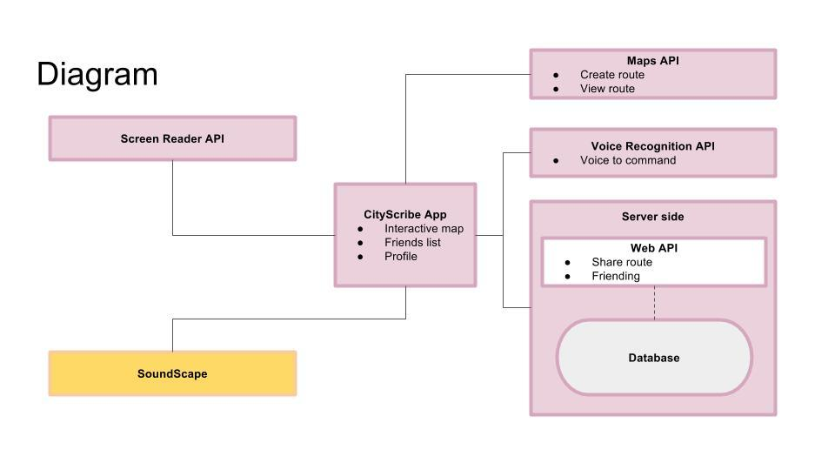

**Meetings**

*Wednesday 9th November 2016-Client meeting*

We have presented our ideas to the client and discussed the use cases of the features, the timeline for each component of the feature and the technical problems we might have in the future. Our client shared with us his thoughts about the slide presentation and provided us and the 4th year EE students with the priority of the tasks we have to complete by the end of the year. We were asked to break the priority items down into the next level and present the approach we are going to follow in order to design, deliver, research and test the solutions.

List of priority items:

1. Route-sharing and remote navigation
2. Route suggestions
3. Presenting trending Pol’s
4. Audio/Sound Reviews

*Tuesday 15th November 2016*

Clarified with our TA the next steps we have to follow in order to continue our technical research and start coding. We have also discussed the issues that we have met when trying to access the Soundscape and the CityScribe source code submitted by the Msc students in 2015.During this meeting we decided that the SDK we are going to use is Ionic and for the hosting of the webserver we are going to work in Laravel , a PHP open-source web framework. Another topic that was covered were the Web API’s needed for the project. We have managed to find a Microsoft Routes API which will allow us to calculate a route, to route the data and help us deal with the maneuver types. The main problems we discussed were about how a visually impaired would interact with the mobile app. In order to find the answers for our problems we have e-mailed the representative of Guide Dogs, Chris Yates, who will help us understand more about the way our users will use the smartphone.

There were 4 main problems:

-Users receiving the information

-How many steps would take the user to complete a one-step task for the sighted people

-The input of the information

-What should be the main activities a user should do for the purpose of route memorization.

*Thursday 17th November 2016*

Defined more precisely the solution that we are going to implement and methods that we are going to take. Below is just a summary of some of those aspects..

System Overview

The system will be broken into 2 main parts: Web server and Client app. The web server is required to host web apis that CRUD data, serve “routes” function and keeping track of profiles. The client app interacts with users, particularly visually impaired users. The main challenge of the client app is designing a user interface that focuses on the interaction of visually impaired users so that it may feel natural to them.

Tools

Server: PHP/ Laravel framework  
Client App: Ionic, and if Soundscape used then C#  
Build Platform: IOS  
Web APIs: Screen Reader (MS Active Accessibility), Maps, Azure Cognitive Services/ Luis  
Database: Insufficient research into storing lats and lons of coordinates

Version Control: GitHub  
Hosting: Azure

Design

Server side: UML

Client side: Flowchart

Development

Iterative and incremental development

Prototype development

Testing

Unit, functional and acceptance testing where appropriate.

**Tasks completed**

* Looked, in more detail, at MSc 2015 Summer final project, Mobility Instructor App.
* Set up the milestones and requirements
* Agreed on concrete concepts to discuss with the client.
* Decided the processes and tools we are going to use
* Wrote down the method of design, deliver, research and test.
* Set the individual responsibilities and timeline.
* Researched the web technologies we are to use
* Created the website
* Set up the system diagram

**Problems**

* The way the visually impaired will interact with our app
* Refine the scope of our project ideas so that it is achievable.
* Accessing the Soundscape source code provided by previous students.

**Plan**

* Complete the research on the technical tools and Web API’s
* Start experimenting with the technologies
* Finish our website
* Each task leader should start planning out a timeline.
* Start creating the prototype
* Create the web server
* Focus on building individual blocks to test
* Meet our client on 24th November

**Individual Milestones**

Ti Ern Ryan Tan

In the last 2 weeks, I came up with the technical aspects and proposed timeline of the route sharing and remote navigation feature and routes suggestion feature that was mentioned as one of the implementation ideas. Our clients have given the green light to go on with the next steps of development. Since our client had given us the green light, I looked closer into the code of previous work and managed to launch the app that was build by students before us. In our last team meeting, as technical lead, I had come up with more concise methods of implementation and a more precise timeline. I had also narrowed down the technologies with the help and input of my team. I also participated in breaking down the features into 7 feature blocks. Also, I had redesigned the website using static site generator Jekyll for a cleaner and more organised look.

Stefan Manole

I have created a slide presentation indicating the overview of my idea, user case description, the technical aspects and the timeline required for each feature. I have attended our client meeting and started researching the technology tools we need in order to create the priority items we are going go to focus on in this project, Route sharing and route suggestions. I have tried to find out the Web API’s required for creating, saving and sharing the routes .I wrote down the requirements for our app and for our website as well as the individual responsibilities I will have during this project. My responsibilities will involve the Ionic map and profile, the voice recognition feature and the technology research. I have also started to experiment the PHP language and wrote the bi-weekly report.

*.*

Nadia Yael Mahgerefteh

Over the past two weeks I have been working on one of the ideas of being able to display places of interest in the area based on the number of pokes over a certain period. I did some research and was able to generate an algorithm that is able to display the places of interest by the increase of number of pokes. After we had a meeting with our client, we decided to go ahead with the routes sharing idea so I found a few APIs to help us with the app and am learning PHP in order to create the app.